import matplotlib.pyplot as plt
import numpy as np
import pandas as pd
import seaborn as sns
sns.set()
fb = pd.read_csv('FremontBridge.csv', index_col='Date', parse_dates=True)
C:\Users\nikhi\AppData\Local\Temp\ipykernel_35848\1159153605.py:1: UserWarning: Could not infer format, so each element will be parsed individually, falling back to `dateutil`. To ensure parsing is consistent and as-expected, please specify a format.
fb = pd.read_csv('FremontBridge.csv', index_col='Date', parse_dates=True)
fb.head()
Fremont Bridge East Sidewalk \
Date
2012-10-03 00:00:00 9.0
2012-10-03 01:00:00 6.0
2012-10-03 02:00:00 1.0
2012-10-03 03:00:00 3.0
2012-10-03 04:00:00 1.0
Fremont Bridge West Sidewalk
Date
2012-10-03 00:00:00 4.0
2012-10-03 01:00:00 4.0
2012-10-03 02:00:00 1.0
2012-10-03 03:00:00 2.0
2012-10-03 04:00:00 6.0
fb.columns=["East","West"]
# fb['Total'] = fb['East'] + fb['West']
fb['Total'] = fb.eval('East + West')
fb.head(5)
East West Total
Date
2012-10-03 00:00:00 9.0 4.0 13.0
2012-10-03 01:00:00 6.0 4.0 10.0
2012-10-03 02:00:00 1.0 1.0 2.0
2012-10-03 03:00:00 3.0 2.0 5.0
2012-10-03 04:00:00 1.0 6.0 7.0
fb.isna().sum()
East 9
West 9
Total 9
dtype: int64
fb.dropna(inplace=True)
fb.plot( figsize=(16,6))
plt.legend(loc='upper left')
plt.ylabel('Hourly Bicycle Count')
# Obsevation: The 30k+ samples are way too dense to make sense, because we hardly see East and West data ata the bottom.
Text(0, 0.5, 'Hourly Bicycle Count')
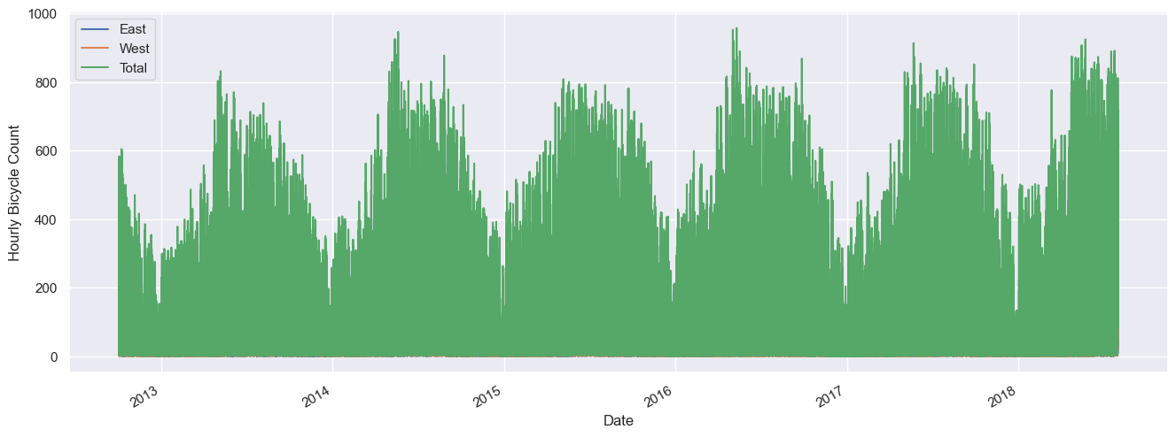
fb_daily = fb.resample('d').sum()
print('fb_daily size :',fb_daily.size)
fb_daily.plot(kind='line', figsize=(16,6))
plt.ylabel('Daily Bicycle Count')
# Observation: It's still dense with daily data.
fb_daily size : 6384
Text(0, 0.5, 'Daily Bicycle Count')
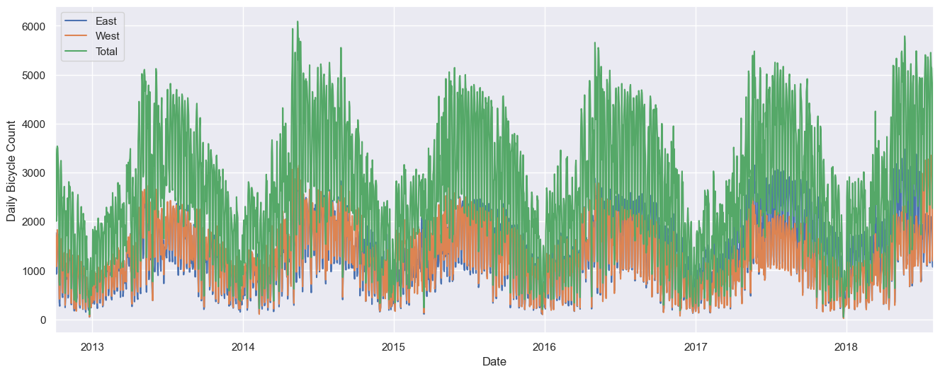
fb_weekly = fb_daily.resample('W').sum()
print('fb_weekly size :',fb_weekly.size)
fb_weekly.plot(kind='line', figsize=(16,6))
plt.ylabel('Weekly Bicycle Count')
fb_weekly size : 915
Text(0, 0.5, 'Weekly Bicycle Count')
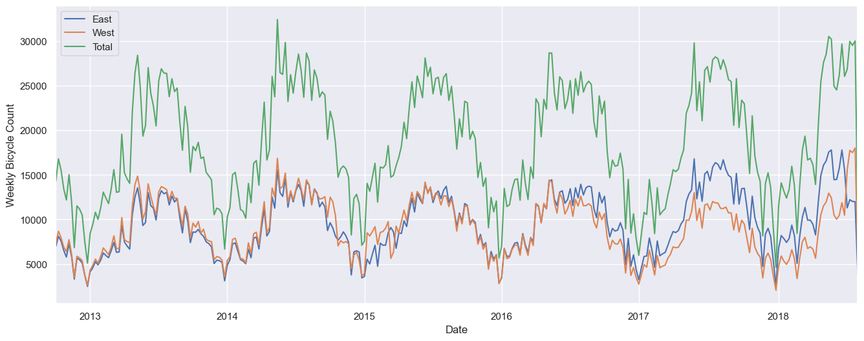
# We might want to look at the average traffic as a function of the time of day.
gby_time = fb.groupby(fb.index.time).mean()
hourly_ticks = 60 * 60 * np.arange(24)
print('Hourly Ticks :', hourly_ticks)
gby_time.plot(xticks=hourly_ticks,figsize=(12,6))
plt.xticks(rotation='vertical')
Hourly Ticks : [ 0 3600 7200 10800 14400 18000 21600 25200 28800 32400 36000 39600
43200 46800 50400 54000 57600 61200 64800 68400 72000 75600 79200 82800]
(array([ 0, 3600, 7200, 10800, 14400, 18000, 21600, 25200, 28800,
32400, 36000, 39600, 43200, 46800, 50400, 54000, 57600, 61200,
64800, 68400, 72000, 75600, 79200, 82800]),
[Text(0, 0, '00:00'),
Text(3600, 0, '01:00'),
Text(7200, 0, '02:00'),
Text(10800, 0, '03:00'),
Text(14400, 0, '04:00'),
Text(18000, 0, '05:00'),
Text(21600, 0, '06:00'),
Text(25200, 0, '07:00'),
Text(28800, 0, '08:00'),
Text(32400, 0, '09:00'),
Text(36000, 0, '10:00'),
Text(39600, 0, '11:00'),
Text(43200, 0, '12:00'),
Text(46800, 0, '13:00'),
Text(50400, 0, '14:00'),
Text(54000, 0, '15:00'),
Text(57600, 0, '16:00'),
Text(61200, 0, '17:00'),
Text(64800, 0, '18:00'),
Text(68400, 0, '19:00'),
Text(72000, 0, '20:00'),
Text(75600, 0, '21:00'),
Text(79200, 0, '22:00'),
Text(82800, 0, '23:00')])
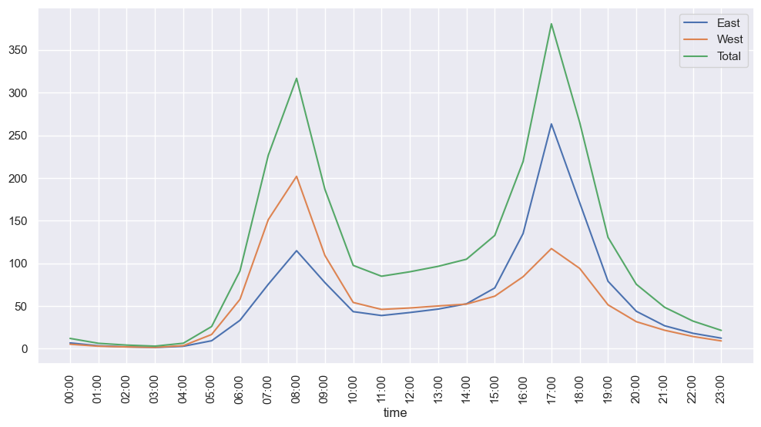
# Again, we can do this with a simple groupby
gby_week = fb.groupby(fb.index.dayofweek).mean()
# print(gby_week)
weekdays = ['Mon', 'Tue', 'Wed', 'Thu', 'Fri', 'Sat', 'Sun']
# print('gby_week index =',gby_week.index.tolist())
# gby_week.index = ['Mon', 'Tue', 'Wed', 'Thu', 'Fri', 'Sat', 'Sun']
# print('gby_week index =',gby_week.index.tolist())
gby_week.plot()
plt.xticks(range(len(weekdays)),weekdays, rotation=45)
plt.show()
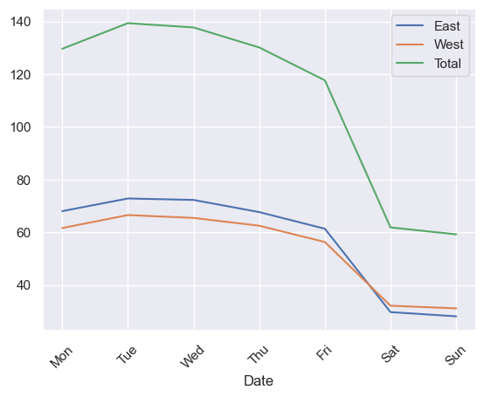
weather=pd.read_csv('BicycleWeather.csv',index_col='DATE',parse_dates=True)
counts=pd.read_csv('FremontBridge.csv', index_col='Date', parse_dates=True)
C:\Users\nikhi\AppData\Local\Temp\ipykernel_35848\2914046239.py:2: UserWarning: Could not infer format, so each element will be parsed individually, falling back to `dateutil`. To ensure parsing is consistent and as-expected, please specify a format.
counts=pd.read_csv('FremontBridge.csv', index_col='Date', parse_dates=True)
weather.head()
STATION STATION_NAME \
DATE
2012-01-01 GHCND:USW00024233 SEATTLE TACOMA INTERNATIONAL AIRPORT WA US
2012-01-02 GHCND:USW00024233 SEATTLE TACOMA INTERNATIONAL AIRPORT WA US
2012-01-03 GHCND:USW00024233 SEATTLE TACOMA INTERNATIONAL AIRPORT WA US
2012-01-04 GHCND:USW00024233 SEATTLE TACOMA INTERNATIONAL AIRPORT WA US
2012-01-05 GHCND:USW00024233 SEATTLE TACOMA INTERNATIONAL AIRPORT WA US
PRCP SNWD SNOW TMAX TMIN AWND WDF2 WDF5 ... WT17 WT05 \
DATE ...
2012-01-01 0 0 0 128 50 47 100 90 ... -9999 -9999
2012-01-02 109 0 0 106 28 45 180 200 ... -9999 -9999
2012-01-03 8 0 0 117 72 23 180 170 ... -9999 -9999
2012-01-04 203 0 0 122 56 47 180 190 ... -9999 -9999
2012-01-05 13 0 0 89 28 61 200 220 ... -9999 -9999
WT02 WT22 WT04 WT13 WT16 WT08 WT18 WT03
DATE
2012-01-01 -9999 -9999 -9999 -9999 -9999 -9999 -9999 -9999
2012-01-02 -9999 -9999 -9999 1 1 -9999 -9999 -9999
2012-01-03 -9999 -9999 -9999 -9999 1 -9999 -9999 -9999
2012-01-04 -9999 -9999 -9999 1 1 -9999 -9999 -9999
2012-01-05 -9999 -9999 -9999 -9999 1 -9999 -9999 -9999
[5 rows x 25 columns]
daily = counts.resample('d').sum()
daily['Total'] = daily.sum(axis=1)
daily = daily[['Total']] # remove other columns
daily
Total
Date
2012-10-03 3521.0
2012-10-04 3475.0
2012-10-05 3148.0
2012-10-06 2006.0
2012-10-07 2142.0
... ...
2018-07-27 4509.0
2018-07-28 2535.0
2018-07-29 2266.0
2018-07-30 4801.0
2018-07-31 5127.0
[2128 rows x 1 columns]
days = ['Mon', 'Tue', 'Wed', 'Thu', 'Fri', 'Sat', 'Sun']
for i in range(7):
daily[days[i]] = (daily.index.dayofweek == i).astype(float)
daily
Total Mon Tue Wed Thu Fri Sat Sun
Date
2012-10-03 3521.0 0.0 0.0 1.0 0.0 0.0 0.0 0.0
2012-10-04 3475.0 0.0 0.0 0.0 1.0 0.0 0.0 0.0
2012-10-05 3148.0 0.0 0.0 0.0 0.0 1.0 0.0 0.0
2012-10-06 2006.0 0.0 0.0 0.0 0.0 0.0 1.0 0.0
2012-10-07 2142.0 0.0 0.0 0.0 0.0 0.0 0.0 1.0
... ... ... ... ... ... ... ... ...
2018-07-27 4509.0 0.0 0.0 0.0 0.0 1.0 0.0 0.0
2018-07-28 2535.0 0.0 0.0 0.0 0.0 0.0 1.0 0.0
2018-07-29 2266.0 0.0 0.0 0.0 0.0 0.0 0.0 1.0
2018-07-30 4801.0 1.0 0.0 0.0 0.0 0.0 0.0 0.0
2018-07-31 5127.0 0.0 1.0 0.0 0.0 0.0 0.0 0.0
[2128 rows x 8 columns]
from pandas.tseries.holiday import USFederalHolidayCalendar
cal = USFederalHolidayCalendar()
holidays = cal.holidays('2012', '2016')
daily = daily.join(pd.Series(1, index=holidays, name='holiday'))
daily['holiday'].fillna(0, inplace=True)
weather['TMIN'] /= 10
weather['TMAX'] /= 10
weather['Temp (C)'] = 0.5 * (weather['TMIN'] + weather['TMAX'])
# precip is in 1/10 mm; convert to inches
weather['PRCP'] /= 254
weather['dry day'] = (weather['PRCP'] == 0).astype(int)
daily = daily.join(weather[['PRCP', 'Temp (C)', 'dry day']])
daily['annual'] = (daily.index - daily.index[0]).days / 365.
daily.head()
Total Mon Tue Wed Thu Fri Sat Sun holiday PRCP \
Date
2012-10-03 3521.0 0.0 0.0 1.0 0.0 0.0 0.0 0.0 0.0 0.0
2012-10-04 3475.0 0.0 0.0 0.0 1.0 0.0 0.0 0.0 0.0 0.0
2012-10-05 3148.0 0.0 0.0 0.0 0.0 1.0 0.0 0.0 0.0 0.0
2012-10-06 2006.0 0.0 0.0 0.0 0.0 0.0 1.0 0.0 0.0 0.0
2012-10-07 2142.0 0.0 0.0 0.0 0.0 0.0 0.0 1.0 0.0 0.0
Temp (C) dry day annual
Date
2012-10-03 13.35 1.0 0.000000
2012-10-04 13.60 1.0 0.002740
2012-10-05 15.30 1.0 0.005479
2012-10-06 15.85 1.0 0.008219
2012-10-07 15.85 1.0 0.010959
# Drop any rows with null values
daily.dropna(axis=0, how='any', inplace=True)
column_names = ['Mon', 'Tue', 'Wed', 'Thu', 'Fri', 'Sat', 'Sun', 'holiday',
'PRCP', 'dry day', 'Temp (C)', 'annual']
X = daily[column_names]
y = daily['Total']
from sklearn.linear_model import LinearRegression
model = LinearRegression(fit_intercept=False)
model.fit(X, y)
daily['predicted'] = model.predict(X)
daily[['Total', 'predicted']].plot(alpha=0.5)
<Axes: xlabel='Date'>
